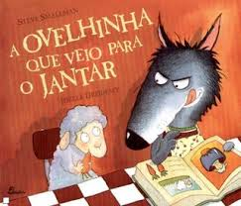

Nome: __________________________________________________

Data: ________

**Tarefa 5**

1. Copia a parte do texto que mais gostaste e ilustra-a.

____________________________________________________________________________________________________________________________________________________________________________________________________________________________________________________________________________________________________________________________________________________________________________________________________________________________________

____________________________________________________________________________________________________________________________________________